

Mark Scheme (Final)

Summer 2007

Edexcel Limited. Registered in England and Wales No. 4496750
Registered Office: One90 High Holborn, London WC1V 7BH


GCE



GCE Mathematics (6663/01)

General Principal for Pure Mathematics Marking

(But note that specific mark schemes may sometimes override these general principles).

Method mark for solving 3 term quadratic:

1. Factorisation

, leading to x = …

, leading to x = …

2. Formula

Attempt to use correct formula (with values for a, b and c).

3. Completing the square

Solving 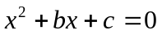: 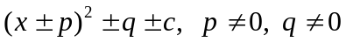, leading to x = …

Method marks for differentiation and integration:

1. Differentiation

Power of at least one term decreased by 1. (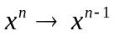)

2. Integration

Power of at least one term increased by 1. (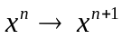)

Use of a formula

Where a method involves using a formula that has been learnt, the advice given in recent examiners’ reports is that the formula should be quoted first.

Normal marking procedure is as follows:

Method mark for quoting a correct formula and attempting to use it, even if there are mistakes in the substitution of values.

Where the formula is not quoted, the method mark can be gained by implication from correct working with values, but may be lost if there is any mistake in the working.

Exact answers

Examiners’ reports have emphasised that where, for example, an exact answer is asked for, or working with surds is clearly required, marks will normally be lost if the candidate resorts to using rounded decimals.

Answers without working

The rubric says that these may not gain full credit. Individual mark schemes will give details of what happens in particular cases. General policy is that if it could be done “in your head”, detailed working would not be required. Most candidates do show working, but there are occasional awkward cases and if the mark scheme does not cover this, please contact your team leader for advice.

June 2007

6663 Core Mathematics C1

Mark Scheme

Question Scheme Marks
number

1. 9 – 5 or 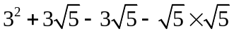 or 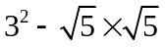 or 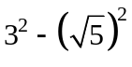 M1

= 4 A1cso (2)

2

M1 for an attempt to multiply out. There must be at least 3 correct terms. Allow one sign slip

only, no arithmetic errors.

e.g. 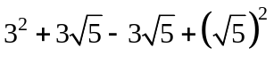 is M1A0

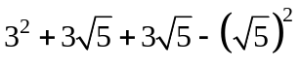 is M1A0 as indeed is 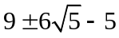

BUT 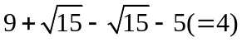 is M0A0 since there is more than a sign error.

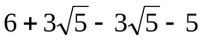 is M0A0 since there is an arithmetic error.

If all you see is 9 + 5 that is M1 but please check it has not come from incorrect working.

Expansion of 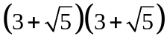 is M0A0

A1cso for 4 only. Please check that no incorrect working is seen.

Correct answer only scores both marks.

Question Scheme Marks
number

2. (a) Attempt 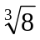 or 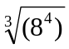 M1
= 16 A1 (2)
(b) 5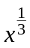 5, B1, B1 (2)

4

(a) M1 for: 2 (on its own) or 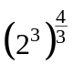 or 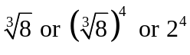 or 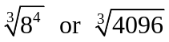

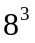 or 512 or 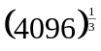is M0

A1 for 16 only

(b) 1st B1 for 5 on its own or something.

So e.g. 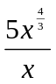 is B1 But 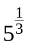 is B0

An expression showing cancelling is not sufficient

(see first expression of QC0184500123945 the mark is scored for the second expression)

2nd B1 for

Can use ISW (incorrect subsequent working)

e.g 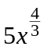 scores B1B0 but it may lead to 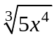 which we ignore as ISW.

Correct answers only score full marks in both parts.

Question Scheme Marks
number

3. (a) 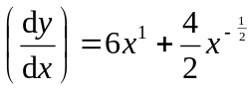 or 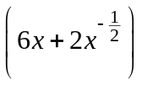 M1 A1 (2)
(b) 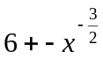 or 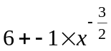 M1 A1ft (2)

(c) 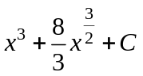 A1: 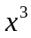 or 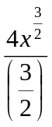 A1: both, simplified and + C M1 A1 A1 (3)

7

(a) M1 for some attempt to differentiate: 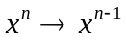

Condone missing 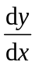 or y = …

A1 for both terms correct, as written or better. No + C here. Of course 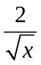 is acceptable.

(b) M1 for some attempt to differentiate again. Follow through their , at least one term correct

or correct follow through.

A1f.t. as written or better, follow through must have 2 distinct terms and simplified e.g. 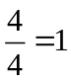.

(c) M1 for some attempt to integrate: 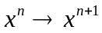. Condone misreading 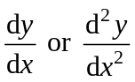 for y.

(+C alone is not sufficient)

1st A1 for either or (or better) 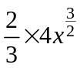 is OK here too but not for 2nd A1.

2nd A1 for both and 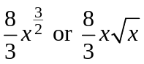 i.e. simplified terms and +C all on one line.

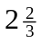 instead of is OK

Question Scheme Marks
number

4. (a) Identify a = 5 and d = 2 (May be implied) B1
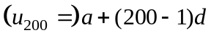 (= 5 + (200 – 1)2 ) M1
= 403(p) or (£) 4.03 A1 (3)
(b) 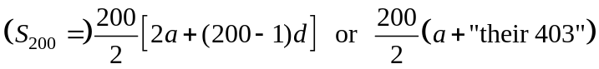 M1
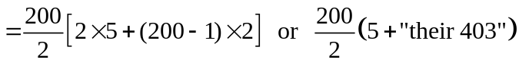 A1
= 40 800 or £408 A1 (3)

6

(a) B1 can be implied if the correct answer is obtained. If 403 is not obtained then the values of

a and d must be clearly identified as a = 5 and d = 2.

This mark can be awarded at any point.

M1 for attempt to use nth term formula with n = 200. Follow through their a and d.

Must have use of n = 200 and one of a or d correct or correct follow through.

Must be 199 not 200.

A1 for 403 or 4.03 (i.e. condone missing £ sign here). Condone £403 here.

N.B. a = 3, d = 2 is B0 and a + 200d is M0 BUT 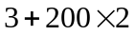 is B1M1 and A1 if it leads to 403.

Answer only of 403 (or 4.03) scores 3/3.

(b) M1 for use of correct sum formula with n = 200. Follow through their a and d and their 403.

Must have some use of n = 200,and some of a, d or l correct or correct follow through.

1st A1 for any correct expression (i.e. must have a = 5 and d = 2) but can f.t. their 403 still.

2nd A1 for 40800 or £408 (i.e. the £ sign is required before we accept 408 this time).

40800p is fine for A1 but £40800 is A0.

ALT Listing

(a) They might score B1 if a =5 and d = 2 are clearly identified. Then award M1A1 together for 403.

(b) 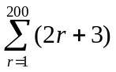. Give M1 for 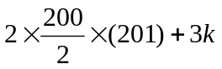(with k >1), A1 for k = 200 and A1 for 40800.

Question Scheme Marks
number

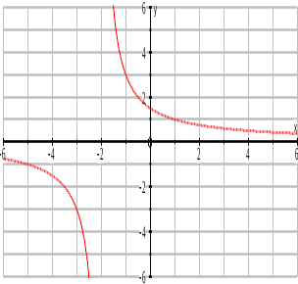
5. (a)

Translation parallel to x-axis M1

Top branch intersects +ve y-axis

Lower branch has no intersections A1

No obvious overlap

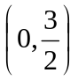 or  marked on y- axis B1 (3)

(b) 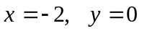 B1, B1 (2)

S.C. [Allow ft on first B1 for x = 2 when translated “the wrong way” but must be

compatible with their sketch.]

5

(a) M1 for a horizontal translation – two branches with one branch cutting y – axis only.

If one of the branches cuts both axes (translation up and across) this is M0.

A1 for a horizontal translation to left. Ignore any figures on axes for this mark.

B1 for correct intersection on positive y-axis. More than 1 intersection is B0.

x=0 and y = 1.5 in a table alone is insufficient unless intersection of their sketch is with +ve y-axis.

A point marked on the graph overrides a point given elsewhere.

(b) 1st B1 for . NB x 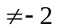 is B0.

Can accept x = +2 if this is compatible with their sketch.

Usually they will have M1A0 in part (a) (and usually B0 too)

2nd B1 for y = 0.

S.C. If x = -2 and y =0 and some other asymptotes are also given award B1B0

The asymptote equations should be clearly stated in part (b). Simply marking x =-2 or y =0

on the sketch is insufficient unless they are clearly marked “asymptote x = -2” etc.

Question Scheme Marks
number

6. (a) 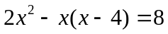 M1

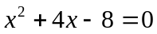 (*) A1cso (2)

(b) 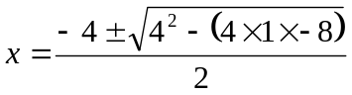 or 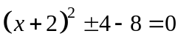 M1

x = - 2 + (any correct expression) A1

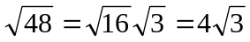 or 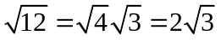 B1

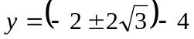 M: Attempt at least one y value M1

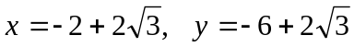 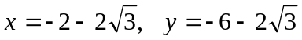 A1 (5)

7

(a) M1 for correct attempt to form an equation in x only. Condone sign errors/slips but attempt at

this line must be seen. E.g. 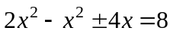 is OK for M1.

A1cso for correctly simplifying to printed form. No incorrect working seen. The = 0 is required.

These two marks can be scored in part (b). For multiple attempts pick best.

(b) 1st M1 for use of correct formula. If formula is not quoted then a fully correct substitution is

required. Condone missing x = or just + or – instead of + for M1.

For completing the square must have as printed or better.

If they have 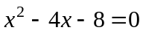 then M1 can be given for 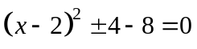.

1st A1 for -2 + any correct expression. (The + is required but x = is not)

B1 for simplifying the surd e.g. 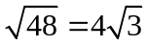. Must reduce to b so 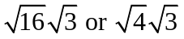 are OK.

2nd M1 for attempting to find at least one y value. Substitution into one of the given equations

and an attempt to solve for y.

2nd A1 for correct y answers. Pairings need not be explicit but they must say which is x and which y.

Mis-labelling x and y loses final A1 only.

Question Scheme Marks
number

7. (a) Attempt to use discriminant 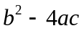 M1

(*) A1cso (2)

(b) 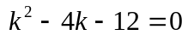 

M1

k = –2 and 6 (both) A1

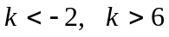 or 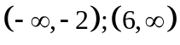 M: choosing “outside” M1 A1ft (4)

6

(a) M1 for use of , one of b or c must be correct.

Or full attempt using completing the square that leads to a 3TQ in k

e.g. 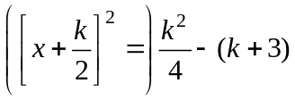

A1cso Correct argument to printed result. Need to state (or imply) that >0 and no

incorrect working seen. Must have >0. If > 0 just appears with 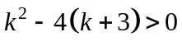that is OK.

If >0 appears on last line only with no explanation give A0.

followed by 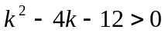 only is insufficient so M0A0

e.g. 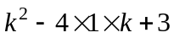 (missing brackets) can get M1A0 but 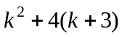is M0A0 (wrong formula)

Using 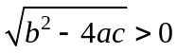 is M0.

(b) 1st M1 for attempting to find critical regions. Factors, formula or completing the square.

1st A1 for k = 6 and  only

2nd M1 for choosing the outside regions

2nd A1f.t. as printed or f.t. their (non identical) critical values

6 < k < is M1A0 but ignore if it follows a correct version

< k < 6 is M0A0 whatever their diagram looks like

Condone use of x instead of k for critical values and final answers in (b).

Treat this question as 3 two mark parts. If part (a) is seen in (b) or vice versa marks can be awarded.

Question Scheme Marks
number

8. (a) 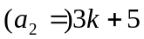 [must be seen in part (a) or labelled 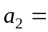 ] B1 (1)

(b) 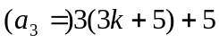 M1

= 9k + 20 (*) A1cso (2)

(c)(i) 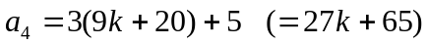 M1

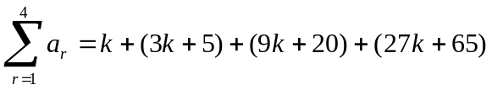 M1

(ii) = 40k + 90 A1

= 10(4k + 9) (or explain why divisible by 10) A1ft (4)

7

(b) M1 for attempting to find 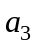, follow through their 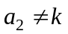.

A1cso for simplifying to printed result with no incorrect working seen.

(c) 1st M1 for attempting to find 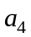. Can allow a slip here e.g. 3(9k + 20) [i.e. forgot +5]

2nd M1 for attempting sum of 4 relevant terms, follow through their (a) and (b).

Must have 4 terms starting with k.

Use of arithmetic series formulae at this point is M0A0A0

1st A1 for simplifying to 40k + 90 or better

2nd A1ft for taking out a factor of 10 or dividing by 10 or an explanation in words true 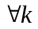.

Follow through their sum of 4 terms provided that both Ms are

scored and their sum is divisible by 10.

A comment is not required.

e.g. 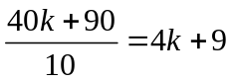 is OK for this final A1.

S.C. 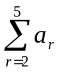= 120k + 290 = 10(12k + 29) can have M1M0A0A1ft.

Question Scheme Marks
number

9. (a) 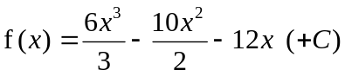 M1 A1

x = 5: 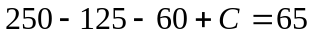 C = 0 M1 A1 (4) (b) 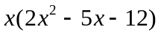 or 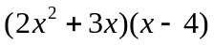 or 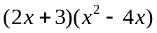 M1

= 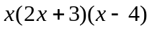 (*) A1cso (2)

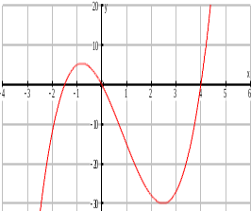
(c)

Shape B1

Through origin B1

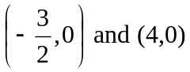 B1 (3)

9

(a) 1st M1 for attempting to integrate, 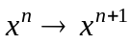

1st A1 for all x terms correct, need not be simplified. Ignore + C here.

2nd M1 for some use of x = 5 and f(5)=65 to form an equation in C based on their integration.

There must be some visible attempt to use x = 5 and f(5)=65. No +C is M0.

2nd A1 for C = 0. This mark cannot be scored unless a suitable equation is seen.

(b) M1 for attempting to take out a correct factor or to verify. Allow usual errors on signs.

They must get to the equivalent of one of the given partially factorised expressions or, if verifying, 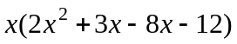i.e. with no errors in signs.

A1cso for proceeding to printed answer with no incorrect working seen. Comment not required.

This mark is dependent upon a fully correct solution to part (a) so M1A1M0A0M1A0 for (a) & (b).

Will be common or M1A1M1A0M1A0. To score 2 in (b) they must score 4 in (a).

(c) 1st B1 for positive 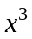shaped curve (with a max and a min) positioned anywhere.

2nd B1 for any curve that passes through the origin (B0 if it only touches at the origin)

3rd B1 for the two points clearly given as coords or values marked in appropriate places on x axis.

Ignore any extra crossing points (they should have lost first B1).

Condone (1.5, 0) if clearly marked on –ve x-axis. Condone (0, 4) etc if marked on +ve x axis.

Curve can stop (i.e. not pass through) at (-1.5, 0) and (4, 0).

A point on the graph overrides coordinates given elsewhere.

Question Scheme Marks
number

10. (a) 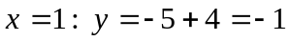, 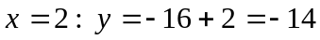 (can be given 1st B1 for – 1

in (b) or (c)) 2nd B1 for - 14

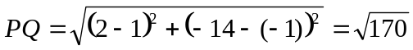 (*) M1 A1cso (4)

(b) 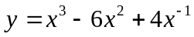 M1

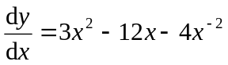 M1 A1

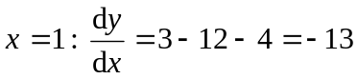 M: Evaluate at one of the points M1

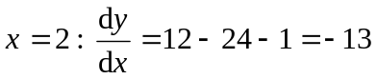 ∴Parallel A: Both correct + conclusion A1 (5) (c) Finding gradient of normal 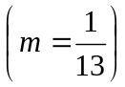 M1

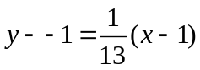 M1 A1ft

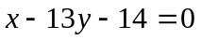 o.e. A1cso (4)

13

(a) M1 for attempting PQ or 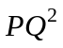 using their P and their Q. Usual rules about quoting formulae.

We must see attempt at 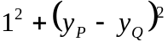 for M1. 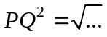 etc could be M1A0.

A1cso for proceeding to the correct answer with no incorrect working seen.

(b) 1st M1 for multiplying by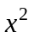, the 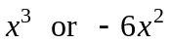 must be correct.

2nd M1 for some correct differentiation, at least one term must be correct as printed.

1st A1 for a fully correct derivative.

These 3 marks can be awarded anywhere when first seen.

3rd M1 for attempting to substitute x = 1 or x = 2 in their derivative. Substituting in y is M0.

2nd A1 for -13 from both substitutions and a brief comment.

The – 13 must come from their derivative.

(c) 1st M1 for use of the perpendicular gradient rule. Follow through their – 13.

2nd M1 for full method to find the equation of the normal or tangent at P. If formula is

quoted allow slips in substitution, otherwise a correct substitution is required.

1st A1ft for a correct expression. Follow through their – 1 and their changed gradient.

2nd A1cso for a correct equation with = 0 and integer coefficients.

This mark is dependent upon the – 13 coming from their derivative in (b) hence cso.

Tangent can get M0M1A0A0, changed gradient can get M0M1A1A0orM1M1A1A0.

Condone confusion over terminology of tangent and normal, mark gradient and equation.

MR Allow for 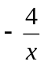 or (x+6) but not omitting 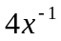 or treating it as 4x.

Question Scheme Marks
number

11. (a) 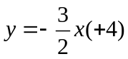 Gradient = 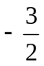 M1 A1 (2)

(b) 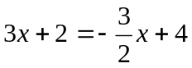 x =…, 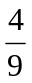 M1, A1

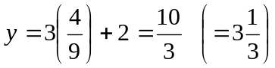 A1 (3)

(c) Where y = 1, 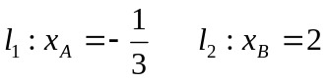 M: Attempt one of these M1 A1

Area = 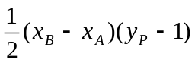 M1

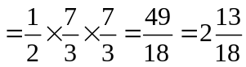 o.e. A1 (4)

9

(a) M1 for an attempt to write 3x + 2y – 8 =0 in the form y = mx + c

or a full method that leads to m = , e.g find 2 points, and attempt gradient using 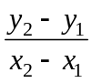

e.g. finding y = -1.5x + 4 alone can score M1 (even if they go on to say m = 4)

A1 for m = 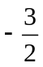 (can ignore the +c) or 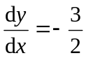

(b) M1 for forming a suitable equation in one variable and attempting to solve leading to x= ..or y=

1st A1 for any exact correct value for x

2nd A1 for any exact correct value for y

(These 3 marks can be scored anywhere, they may treat (a) and (b) as a single part)

(c) 1st M1 for attempting the x coordinate of A or B. One correct value seen scores M1.

1st A1 for 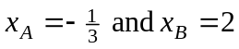

2nd M1 for a full method for the area of the triangle – follow through their 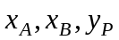.

e.g. determinant approach 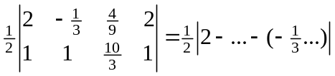

2nd A1 for 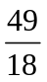or an exact equivalent.

All accuracy marks require answers as single fractions or mixed numbers not necessarily in lowest terms.

